Interpreter
(Behavioural)

The Interpreter design pattern in Java is a behavioral design pattern that defines a way to interpret and evaluate language grammar or expressions. It provides a mechanism to evaluate sentences in a language by representing their grammar as a set of classes.
Real-Life analogy of Interpreter Design Pattern
Imagine you are traveling to a foreign country where you do not speak the native language. In such a scenario, you may need the assistance of an interpreter to help you communicate effectively with the locals.
Interpreter Design Pattern example
Suppose we have a simple language that supports basic arithmetic operations, such as addition (+), subtraction (-), multiplication (*), and division (/). We want to create a calculator program that can interpret and evaluate arithmetic expressions written in this language.
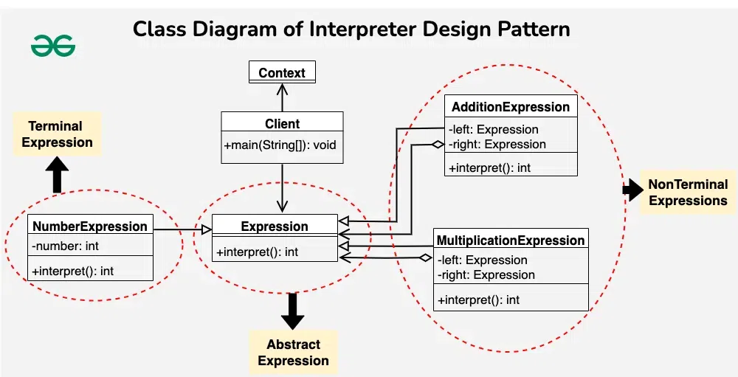

1. Context
public class Context {
// Any global information needed for interpretation
}

2. Abstract Expression
public interface Expression {
int interpret(Context context);
}

3. Terminal Expression
public class NumberExpression implements Expression {
private int number;

public NumberExpression(int number) {
this.number = number;
}

@Override
public int interpret(Context context) {
return number;
}
}

5. Non-Terminal Expression
public class AdditionExpression implements Expression {
private Expression left;
private Expression right;

public AdditionExpression(Expression left, Expression right) {
this.left = left;
this.right = right;
}

@Override
public int interpret(Context context) {
return left.interpret(context) + right.interpret(context);
}
}

public class MultiplicationExpression implements Expression {
private Expression left;
private Expression right;

public MultiplicationExpression(Expression left, Expression right) {
this.left = left;
this.right = right;
}

@Override
public int interpret(Context context) {
return left.interpret(context) * right.interpret(context);
}
}

Step 5 (Client Code)
public class Client {
public static void main(String[] args) {
// Input expression
String expression = "2 + 3 * 4";

// Create interpreter
Context context = new Context();
Interpreter interpreter = new Interpreter(context);

// Interpret expression
int result = interpreter.interpret(expression);
System.out.println("Result: " + result);
}
}

Output:
Result: 14
Resources:
https://www.geeksforgeeks.org/interpreter-design-pattern-in-java/

